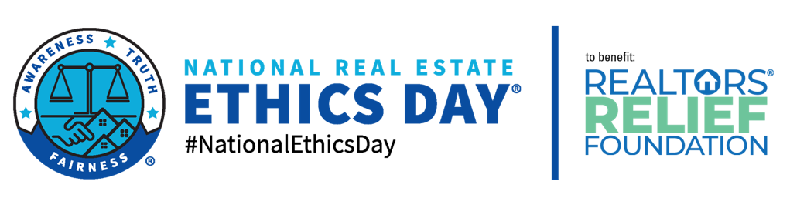
PRESS RELEASE
FOR IMMEDIATE RELEASE
Leigh Brown, CEO and REALTOR® Evangelist
Leigh Thomas Brown, Inc.
ethics@leighbrown.com
704-705-7036
ASSOCIATION NAME Teams Up with Nationally Recognized Speaker for Fifth Annual National Real Estate Ethics Day®
Leigh Brown to Moderate National Ethics Event Via Live Broadcast
CITY, STATE – DATE – Leigh Brown, CEO of One Community Real Estate®, is spearheading the fifth annual nationwide fundraiser and training event on July 7, 2022. Brown will teach the National Association of REALTORS® Code of Ethics class to participating REALTOR® associations across the United States. ASSOCIATION NAME is proud to sponsor this event which is a nationwide fundraiser for the REALTORS® Relief Foundation.
National Association of REALTORS® NAR's Code of Ethics, adopted in 1913, was one of the first codifications of ethical duties adopted by any business group. The Code ensures that consumers are served by requiring REALTORS® to cooperate with each other in furthering clients' best interests. REALTOR® members must complete 2.5 hours of ethics training, meeting specific learning objectives and criteria, within three-year cycles.
As former EVP William D. North wrote, "To endure, the Code must be a criterion of excellence while at the same time constituting a realistic standard of performance. It must be a guide to measure professional conduct, while at the same time representing the furthest reach of professional aspiration. The Code must remain constant without becoming absolute, must be enforceable without being oppressive, and must be meaningful without being dogmatic. To REALTORS®, the Code of Ethics offers the lessons of hindsight, the guidance of foresight, and the understanding of insight.
“This is my gift to my profession — we're going to make a giant gift to the REALTORS® Relief Foundation.” said Brown. “When major disaster strikes, the REALTORS® Relief Foundation has one goal: help families who have endured unimaginable loss. Natural disasters continue to happen – pandemic or not. Our support will help RRF continue meeting the immediate housing needs of disaster victims.
“This is going to be fun! We're going to get the hashtag trending again #NationalEthicsDay and get our REALTOR® members talking about what it means to be bound by the code of ethics. Not just talking about it like words on paper.”
The National Code of Ethics class will be broadcast LIVE! Thursday, July 7, 2022 from 10:00am – 1:00pm PST (1:00pm – 4:00pm EST) from Citrus Valley Association of REALTORS® in Gendora, CA. More information about the event can be found on Website (nationalethicsday.com) and Facebook (@NationalCodeofEthicsDay). #NationalEthicsDay
REALTORS® RELIEF FOUNDATION – The REALTORS® Relief Foundation (RRF) is a charitable organization dedicated to providing housing-related assistance to victims of disasters. Created as a REALTOR®-driven response to the 9/11 terrorist attacks, RRF continues to restore and rebuild communities effected by disasters such as wildfires, hurricanes, earthquakes, and tornadoes thanks to the generosity of individual REALTORS®, REALTOR® Associations, and affiliated organizations. Together, through the RRF, our community has helped over 17,000 families remain in their homes. Every dollar goes directly to victims of disaster. The National Association of REALTORS® covers 100% of administrative expenses.
https://www.nar.realtor/RRF
LEIGH BROWN - Certified Professional Speaker™ (CSP®) international keynote speaker who happens to be hilarious in an almost-inappropriate-but-still-family-friendly way. Leigh uses her decades of experience as the go-to expert for REALTORS® to help any organization get on track with goal setting and achievement. She knows the secret to solid relationships with clients to ensure that they keep coming back again and again. She talks fast, and every word of it is gold. Leigh’s messages are bold, powerful, and full of a contagious energy that breaks through barriers and skyrockets your organization towards success.

ASSOCIATION add specific info here.

####

